 | 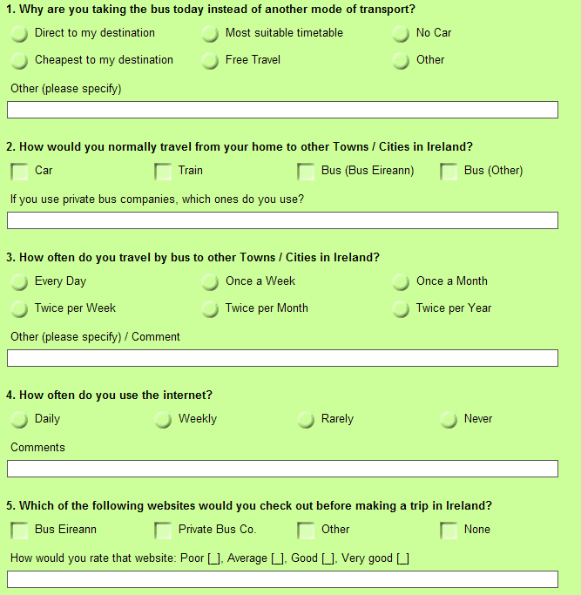  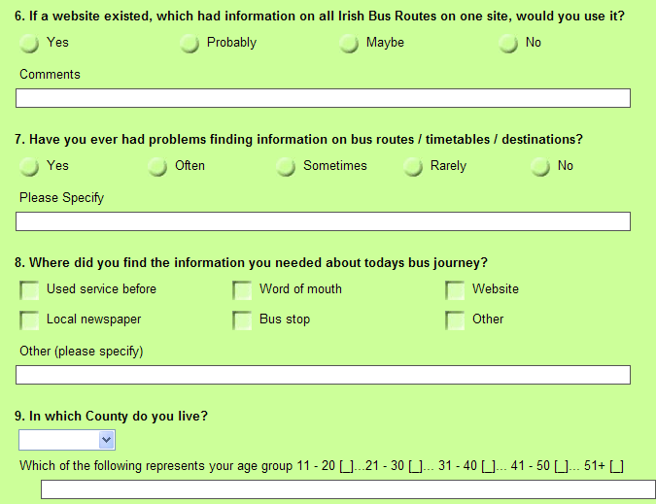  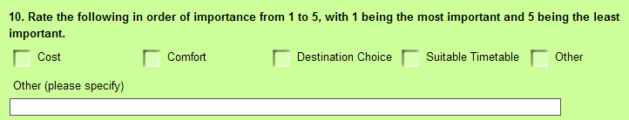 | Bus Passenger Survey  Thank you for taking the time to do this survey. . KBus.ie
 | 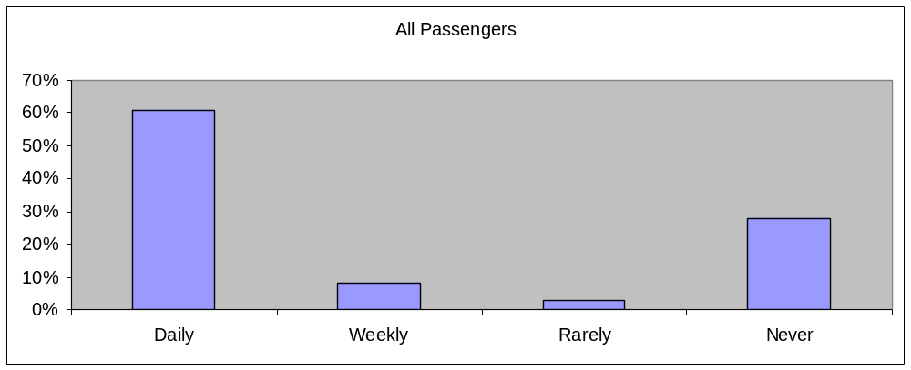  Qu. 4 How often do you use the internet?  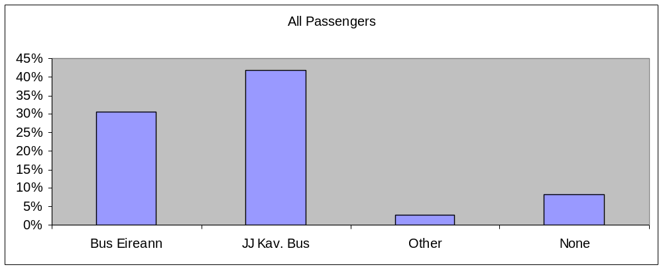  Qu. 5 Which website would you check prior to travelling?  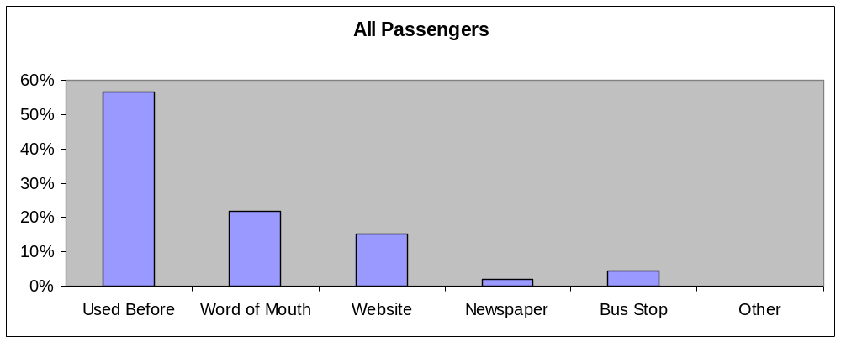  Qu. 8 Where did you get the information for today's journey | Bus Passenger Survey Results  KBus.ie

